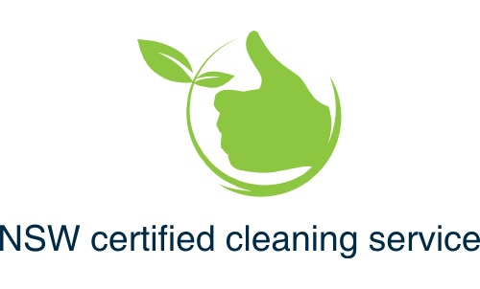

NDIS Cleaning Support You Can Trust
NSW Certified Cleaning Service proudly supports NDIS participants through self-managed and plan-managed funding.
We understand that a clean, safe home plays a vital role in wellbeing, independence, and daily living. Our services are designed to support participants, families, and support coordinators with reliable, professional cleaning delivered to high safety and hygiene standards

Our NDIS Cleaning Services Include
• Regular household cleaning
• Bathroom, kitchen, and living area hygiene
• Infection-control focused cleaning
• Support for participants with sensory, health, or mobility needs
• Flexible scheduling to suit individual routines
All services are provided with care, respect, and attention to individual needs

NDIS Compliance & Safety Standards
While NSW Certified Cleaning Service is not currently NDIS-registered, we proudly support self-managed and plan-managed participants and operate to professional cleaning, safety, and infection-control standards
Our services align with recognised industry frameworks and include:
• ISSA-aligned professional cleaning standards
• IICRC-trained health and safety practices
• Infection control and hygiene protocols
• Fully insured services
• Police-checked workers
• Respectful, confidential, and client-centred service delivery
Full compliance and supporting documentation are available upon request for support coordinators and plan managers.

What You Can Expect When Working With Us
 Clear communication and transparency
Consistent, high-quality cleaning
Respect for participant homes and routines
Professional boundaries and accountability
A calm, reliable service you can trust

How to Get Started
If you are an NDIS participant, family member, or support coordinator seeking a professional cleaning service:
 Request a quote online
Call to speak directly with Jodie
We are happy to answer questions and provide further information to support your decision.
